Web of Science (реферативная БД)
(http://apps.webofknowledge.com)
Самая авторитетная в мире аналитическая и цитатная БД журнальных статей по естественным, техническим, общественным и гуманитарным наукам. Ресурс не содержат полных текстов статей, но включает в себя списки всех библиографических ссылок.
Глубина доступа: 1980 -2015 гг.
Объем: более 12000 журналов
Формат представления данных: html
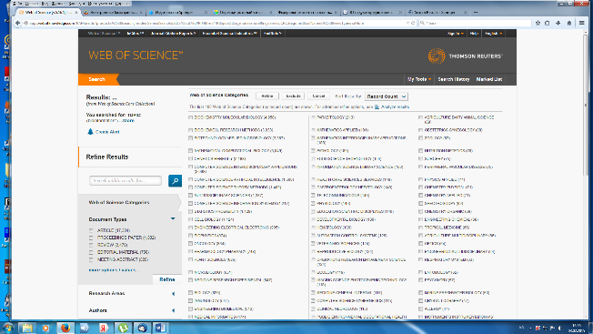
Язык: английский

По теме «Биоинформатика» БД содержит 99 разделов:
- BIOCHEMICAL RESEARCH METHODS (716)
- BIOTECHNOLOGY APPLIED MICROBIOLOGY (622)
- BIOCHEMISTRY MOLECULAR BIOLOGY (621)
- MATHEMATICAL COMPUTATIONAL BIOLOGY (611)
- COMPUTER SCIENCE INTERDISCIPLINARY APPLICATIONS (422)
- GENETICS HEREDITY (305)
- COMPUTER SCIENCE THEORY METHODS (252)
- COMPUTER SCIENCE INFORMATION SYSTEMS (249)
- COMPUTER SCIENCE ARTIFICIAL INTELLIGENCE (226)
- STATISTICS PROBABILITY (207)
- MULTIDISCIPLINARY SCIENCES (201)
- TOXICOLOGY (35)
- PUBLIC ENVIRONMENTAL OCCUPATIONAL HEALTH (34)
- HEALTH CARE SCIENCES SERVICES (34)
- FOOD SCIENCE TECHNOLOGY (30)
- ENDOCRINOLOGY METABOLISM (30)
- MATHEMATICS APPLIED (27)
- MATERIALS SCIENCE MULTIDISCIPLINARY (27)
- MEDICINE GENERAL INTERNAL (25)
- COMPUTER SCIENCE CYBERNETICS (25)
- UROLOGY NEPHROLOGY (13)
- PHYSIOLOGY (13)
- DERMATOLOGY (13)
- IMAGING SCIENCE PHOTOGRAPHIC TECHNOLOGY (12)
- ENGINEERING MULTIDISCIPLINARY (12)
- CHEMISTRY APPLIED (12)
- CELL BIOLOGY (175)
- ENGINEERING ELECTRICAL ELECTRONIC (154)
- BIOLOGY (134)
- PHARMACOLOGY PHARMACY (130)
- CHEMISTRY MULTIDISCIPLINARY (130)
- MEDICAL INFORMATICS (120)
- BIOPHYSICS (106)
- MEDICINE RESEARCH EXPERIMENTAL (100)
- ONCOLOGY (94)
- IMMUNOLOGY (92)
- INFORMATION SCIENCE LIBRARY SCIENCE (90)
- TELECOMMUNICATIONS (24)
- DEVELOPMENTAL BIOLOGY (24)
- NANOSCIENCE NANOTECHNOLOGY (22)
- GASTROENTEROLOGY HEPATOLOGY (22)
- ENGINEERING BIOMEDICAL (86)
- COMPUTER SCIENCE SOFTWARE ENGINEERING (85)
- CHEMISTRY ANALYTICAL (22)
- RADIOLOGY NUCLEAR MEDICINE MEDICAL IMAGING (21)
- PLANT SCIENCES (81)
- EVOLUTIONARY BIOLOGY (21)
- ENGINEERING CHEMICAL (21)
- TROPICAL MEDICINE (19)
- PHYSICS APPLIED (19)
- PARASITOLOGY (18)
- REPRODUCTIVE BIOLOGY (17)
- ENVIRONMENTAL SCIENCES (17)
- ENGINEERING MECHANICAL (11)
- INSTRUMENTS INSTRUMENTATION (10)
- HEMATOLOGY (10)
- ENGINEERING INDUSTRIAL (10)
- ZOOLOGY (9)
- HISTORY PHILOSOPHY OF SCIENCE (9)
- CHEMISTRY PHYSICAL (9)
- RESPIRATORY SYSTEM (8)
- MANAGEMENT (8)
- HORTICULTURE (8)
- ECOLOGY (8)
- CHEMISTRY ORGANIC (8)
- ALLERGY (8)
- EDUCATION SCIENTIFIC DISCIPLINES (74)
- MICROBIOLOGY (56)
- CLINICAL NEUROLOGY (16)
- SURGERY (15)
- OPHTHALMOLOGY (15)
- OPERATIONS RESEARCH MANAGEMENT SCIENCE (15)
- MEDICAL LABORATORY TECHNOLOGY (15)
- SOCIAL SCIENCES MATHEMATICAL METHODS (7)
- PSYCHIATRY (7)
- PERIPHERAL VASCULAR DISEASE (7)
- OPTICS (7)
- INTEGRATIVE COMPLEMENTARY MEDICINE (7)
- CRYSTALLOGRAPHY (7)
- TRANSPLANTATION (6)
- COMPUTER SCIENCE HARDWARE ARCHITECTURE (55)
- INFECTIOUS DISEASES (49)
- EDUCATION EDUCATIONAL RESEARCH (15)
- CARDIAC CARDIOVASCULAR SYSTEMS (15)
- SOCIAL SCIENCES BIOMEDICAL (6)
- SOCIAL ISSUES (6)
- PATHOLOGY (43)
- OBSTETRICS GYNECOLOGY (14)
- PHYSICS CONDENSED MATTER (6)
- PEDIATRICS (6)
- AGRICULTURE DAIRY ANIMAL SCIENCE (6)
- AGRICULTURE MULTIDISCIPLINARY (6)
- VETERINARY SCIENCES (13)
- AUTOMATION CONTROL SYSTEMS (14)
- NUTRITION DIETETICS (14)
- CHEMISTRY MEDICINAL (36)
- MATHEMATICS INTERDISCIPLINARY APPLICATIONS (36)
- NEUROSCIENCES (37)
- VIROLOGY (42)

